Social events of HARMO 22
June 10, from 19:00 to 21:00 – Icebreaker reception in Hestia Hotel Strand, roof bar with great view to the sea. Live harp music by Liis Jürgens.
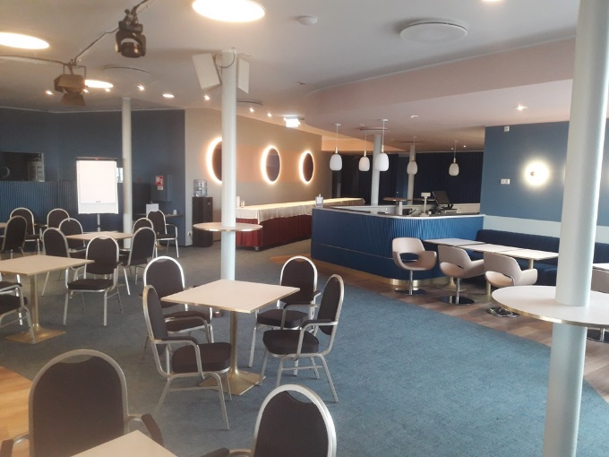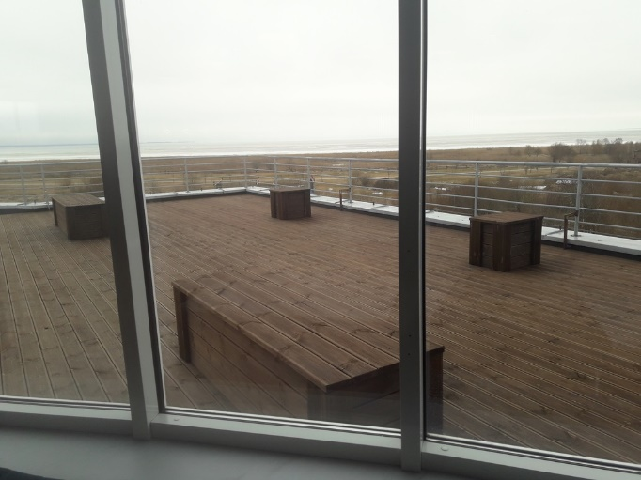

June 11, from 19:00 to 21:00: excursions.
Two alternatives:
- Guided city walking tour – included to participation fee. Begins from Hestia Hotel Strand.
- Visiting the Tahkuse atmospheric measurement station of University of Tartu. For special fee of 15 euros. Pay HERE (scroll town the list of tickets!) or on-site during first two days of HARMO 22 until group is full. Maximum number of visitors is 25. Bus leaves from Hestia Hotel strand at 19:00.
Tahkuse station is located in an old farm on the bank of Pärnu river, at 35 km from Pärnu city. Atmospheric measurements started in 1984. In focus of measurements is nanometer aerosol and air ions, which can grow in the atmosphere and act as condensation nuclei in formation of clouds, thus being a crucial component of climate system.
Photos from Tahkuse. More information in Estonian (rather good translation support in Google Translate is available).

June 12, from 18.45 social dinner
(buses leave from Hestia Hotel Strand): excursion and dinner in Jaanihanso Cider House. Dinner begins nearly at 20:00. Live dance music by Priit Aimla & Band. Buses leave from Jaanihanso to Pärnu nearly at 23:30, arriving back to the hotel shortly after midnight.
NB! Depending on weather, some side activities may take place outside. Please take moderately warm clothing with you, as expected outside temperature at late evening is about +15 °C.

